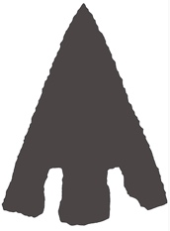
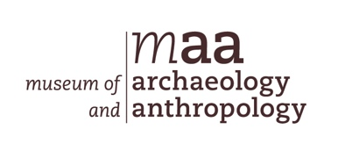
Stone Age to Iron Age

Archaeologists try to understand how people lived in the past by studying the things they left behind, from traces of their homes to the objects they used in their day to day lives. Often, they do this by digging in the ground, archaeologists call this excavating.

Prehistory refers to a time before people wrote things down, a time before written history. In Britain, archaeologists divide prehistory into five time periods: Palaeolithic, Mesolithic, Neolithic, Bronze Age, and Iron Age. The Palaeolithic, Mesolithic and Neolithic are all part of what archaeologists call the Stone Age, a time when people used stone and flint to make weapons and tools. Palaeolithic means old stone age – palaeo meaning old and lithic meaning stone. Mesolithic means middle stone age, the time between the Palaeolithic and the Neolithic. Meso means middle and as we now know lithic means stone. The Neolithic is the new stone age because neo means new. Bronze Age and Iron Age refers to the time people began using metal, at first copper and bronze and later iron. We will now look at each of these prehistoric time periods to find out what life was like for the early inhabitants of Britain.

The Palaeolithic - Old Stone Age - 800 000 BC to 10 500 BC
During the Palaeolithic, Britain was still connected to mainland Europe so people could move freely across the landscape. For thousands of years the climate shifted from warm to cold and people came and went, staying when the weather was favourable and moving away when it became too cold. People would follow herds of animals such as mammoths, hunting them with wooden spears. They ate their meat, used their skins to make clothes and their bones and tusks to make shelters and tools. They also caught fish and gathered roots, fruits, nuts, and shellfish. Some people chose to live in caves, decorating the walls with images of the animals they saw around them. Around 500,000 years ago, people started using flint to make hand axes. Held in the hand, these axes were used to cut up meat, scrape animal hides and to extract marrow from inside bones.

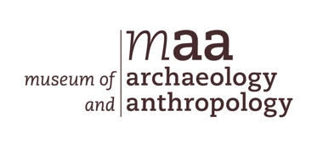
Mesolithic - Middle Stone Age - 10 500 BC to 4000 BC
Over time the climate changed, and the weather became more settled, leading to the appearance of a greater range of animals and plants. People still moved around hunting and gathering, but they often settled in one place for a longer period before moving on. One such place was Star Carr in Yorkshire, where archaeologists found evidence for one of the oldest houses in Britain. They also found tools made from flint, bone, and antler, along with headdresses made from red deer skulls. Archaeologists believe these headdresses may have been worn by shamans, people who may have acted as both a healer and priest.

Neolithic - New Stone Age - 4000 BC to 2400 BC
The Neolithic marked a significant change in the way people lived. This is the time people began farming, planting crops and keeping domesticated animals such as pigs, sheep and cows. They would still have hunted animals and gathered food, but now they relied much more on the animals they reared and the crops they grew. Farming meant people needed to stay longer in one place, and families began settling down, building long wooden houses in which to live and burying their dead in long mounds and chambered tombs. It was during the Neolithic that people began creating circular monuments either by digging ditches or erecting stone and timber circles. Archaeologists are not exactly sure what they were used for, though places like Stonehenge may have been used during ceremonies to remember the ancestors and to mark the longest and shortest days of the year. It was also the first time that people began to make pottery which they used to store and cook food in. While they continued using stone and flint to make axes, they now ground them down using sand and water to make them smooth. Archaeologists call these polished stone axes.

Bronze Age - 2400 BC to 800 BC
Slowly, knowledge of how to make tools and weapons from metal began to spread across Europe from places like Iraq in the Middle East. Producing metal objects by crushing rocks and heating them to a high temperature must have seemed like a magical process. Copper was the first metal to be used which was slowly replaced by bronze, which was made by combining copper with tin. People continued farming but now lived in round wooden houses, often burying their dead in round barrows made of earth, stone, or a combination of both. A type of pottery known as Beakers became popular during this time and they are often found in Bronze Age graves.

Iron Age - 800 BC to 43 AD
Gradually people started using iron instead of bronze, as it was much stronger and could be used to make a wider range of tools, weapons and other objects. In some areas, people built their round houses on the tops of hills surrounding them with ditches, banks and wooden fences. While these hillforts offered protection from potential enemies, they could also be used for ceremonies and places for trading animals and other goods. Gold and silver coins were first used during the late Iron Age and people traded with communities across mainland Europe.

In Britain, the prehistoric period ends when the Romans invaded in 43 AD bringing with them writing and written records.

Questions

Question 1. How do archaeologists try to understand the past?
Question 2. What are the five time periods in British prehistory? Write them in order starting with the oldest first.
Question 3. What does meso and lithic mean?
Question 4. Who do archaeologists think wore headdresses made from red deer skulls?
Question 5. Describe how the Neolithic is different to the Palaeolithic and Mesolithic?
Question 6. Which two metals are combined to make bronze?
Question 7. What is a hillfort, and what were they used for?
Question 8. When does British prehistory end and why?

