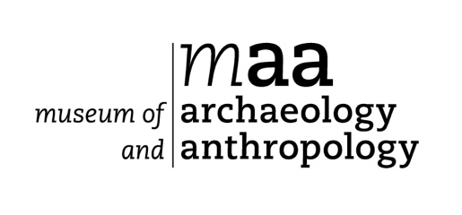
Volunteer Expression of Interest Form
Thank you for your interest in volunteering with the University of Cambridge Museums. Please complete this form and return to: Kate Phizacklea, Visitor Services Manager, Museum of Archaeology and Anthropology, University of Cambridge, Downing Street, Cambridge CB2 3DZ or kp392@cam.ac.uk

In accordance with The University of Cambridge Child and Vulnerable Adult Protection Policy, our Volunteer Programme is normally for those aged 16 or over.

In line with the University’s policy, provided you are volunteering for less than 30 days in a six month period, we will not require you to evidence your right to work

Your contact details
Title | Mr / Mrs / Ms / Miss / Dr / Other:
Given name(s)
Family name
Current address

Post code
Primary telephone
Secondary telephone
E-mail address
Immigration status  (Please ignore this section if you are volunteering for less than 30 days in a 6 month period) | Are you a settled worker (i.e. do you have the permanent right to work/volunteer in the UK – for example as a British or EEA citizen)?  Yes No  If no, do you already have temporary permission to volunteer in the UK?  Yes No  If yes, please specify your visa type and visa end date:
UK National Insurance number (where held)

About you
Please provide a brief outline or any particular skills, interests or experience that you would like to bring to your volunteer role as well as the type of volunteer activity you wish to perform:

How did you hear about volunteering with us?

DBS Check
Volunteers applying for roles that involve working closely with children or vulnerable adults on a frequent or intensive basis will be asked to for a DBS check. We will incur any administrative costs involved. If required for your role, would you be prepared to have an Enhanced CRB check? Yes No

Special Requirements
If you require any special arrangements to be made to attend an initial induction meeting or if you have any medical conditions you’d like us to take into consideration, please specify those below. This information is requested so that we may care for your needs and will be kept confidential.

Emergency Contact Details
Please give details of your next of kin to contact in case of emergency.
Name
Address | Postcode:
Email address
Daytime tel number

Referees
Please give contact details of two people (other than relatives or partners) who have known you for more than 2 years who we can contact to comment on your suitability to volunteer for us.

Referee 1  Name |  | Referee 2  Name
Relationship to you |  | Relationship to you
Email address |  | Email address
Telephone |  | Telephone

Your details will be kept in accordance with the Data Protection Act 1998/2003. They will be held securely and confidentially and accessed only by authorised management. The information given may be used for statistical purposes.

I declare the information I have provided is true and I am over 16 years old:

Signed ........................................................................................... Date ..............................

How the University of Cambridge Museums uses your personal information
The University of Cambridge Museums uses your personal information to contact you about volunteer roles or projects that you have applied for and other related activities.
We use your personal information in order to deliver our contractual obligations to you as a user of our service. More information about our work can be found on our website https://www.museums.cam.ac.uk/
For more information about how we handle your personal information, and your rights under data protection legislation, please see https://www.information-compliance.admin.cam.ac.uk/data-protection/general-data.

