**British Prehistoric Flint Arrowheads**

During prehistoric times, people made arrowheads from flint using a technique called knapping. Knapping involves removing pieces from a larger piece of flint by striking it with a stone hammer. Arrowheads were made by taking some of these smaller flint pieces and carefully shaping them by further knapping, often using smaller tools made from animal bone or deer antler. Below are some examples of British prehistoric flint arrowheads.

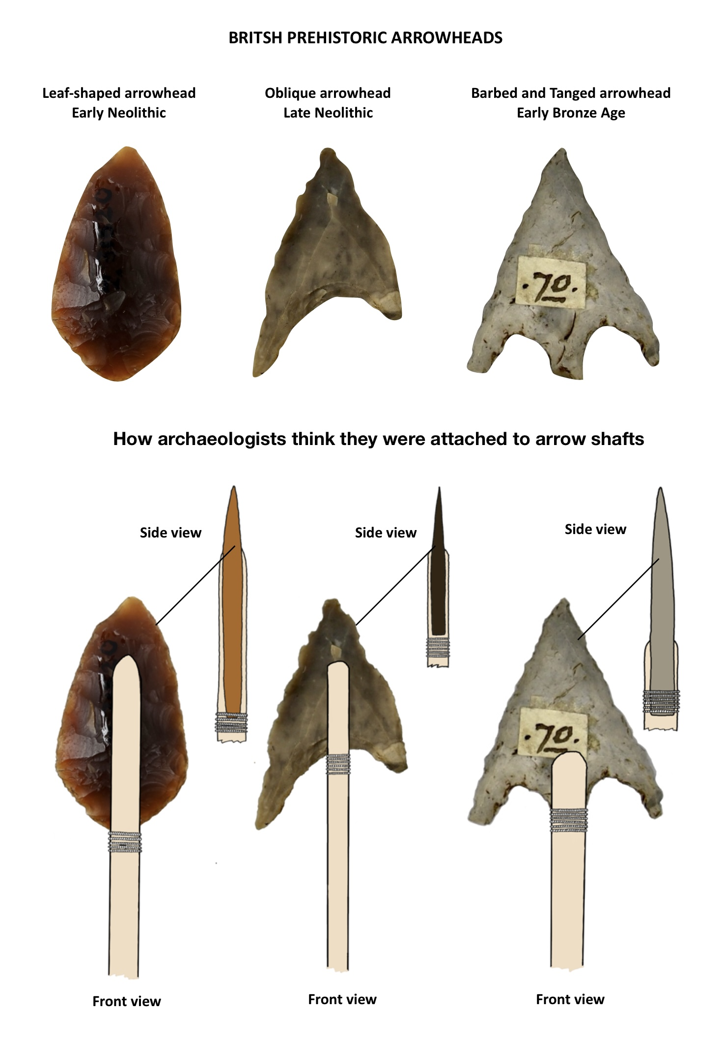

**Prehistoric flint arrowheads**

Leaf-shaped arrowheads date from the early part of the Neolithic (**c.4000-3300 BC**) and are, as their name suggests, leaf-shaped. Oblique arrowheads date from the later part of the Neolithic (**c.2900-2200 BC**) and can be identified by their uneven shape, having one side longer than the other. Their design meant that they lodged in their target and did not easily fall out, which was useful when hunting wild animals. The barbs on an Early Bronze Age (**c.2400-1600 BC**) barbed and tanged arrowhead are the two points on either side of the middle part which is called the tang. The tang is the bit that fits in the groove at the top of the arrow shaft, while the barbs on either side help the arrowhead stay firmly in the target.

Flint arrowheads would have needed to be attached securely to a wooden arrow shaft so they could be used with a bow. While archaeologists know how Early Bronze Age barbed and tanged arrowheads were attached to a wooden arrow shaft, they are less certain of how Neolithic arrowheads were attached. One possible way was to carve out the middle of the wooden shaft and insert the arrowhead in between. Some sort of glue, perhaps made from animal bones or tree bark, would have been needed to keep the arrowhead in place, while twine or fine cord tied around the base of the arrowhead would have stopped the shaft from splitting when the arrow hit its target. The image below shows front and side views of how each type of arrowhead may have been attached to a wooden arrow shaft.

**How archaeologists think flint arrowheads were attached to wooden shafts**

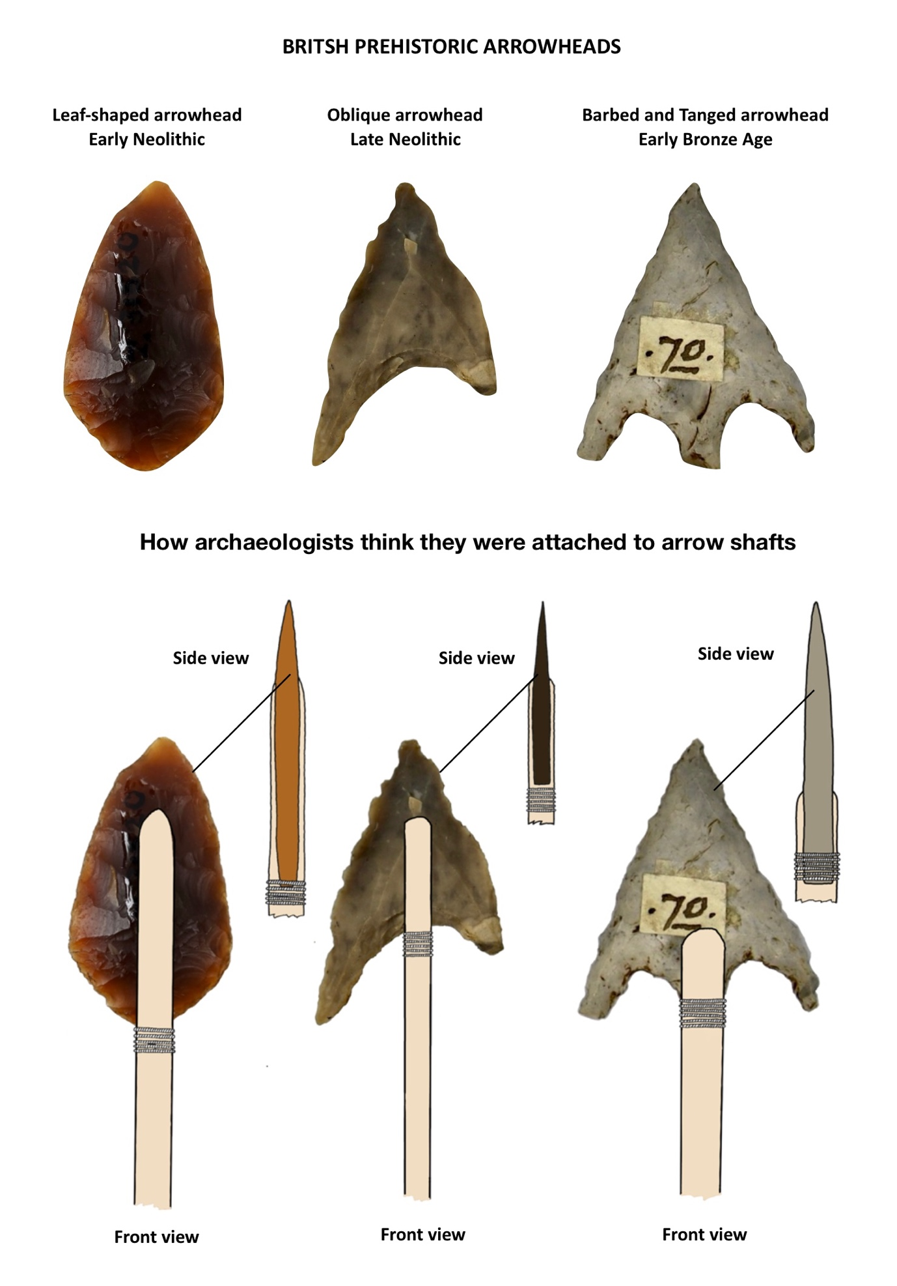

Barb

Tang

**Left to right: Leaf-shaped arrowhead, Oblique arrowhead, Barbed and Tanged arrowhead**