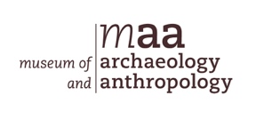
Early Bronze Age Beakers

What are they?

Beakers are a type of pottery that dates from the Early Bronze Age (c.2400-1600 BC). The people who made and used Beakers began arriving in Britain from Europe around 2400 BC bringing with them not only a new style of pottery but also the knowledge of how to make objects from metal.

Beakers have decoration all over their surface made by either drawing a sharp tool through the soft clay or by pressing wooden tools, small bones or fingernails into it. Below are images of two different Beakers, both of which are beautifully decorated.

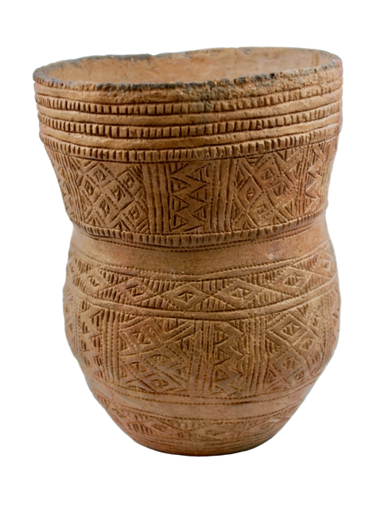
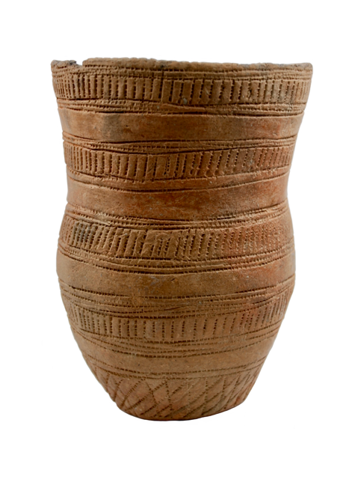

Two different Beakers, both beautifully decorated.

What were they used for?

Archaeologists think Beakers were used as drinking vessels as well as for cooking and storing food. They were also used during funerals, often being placed in a grave next to the dead person’s body.

How were they made?

Beakers were made by hand without the use of a potter’s wheel. Sausage-shaped coils of clay were rolled out and placed one on top of the other to form the walls of the pot. The images below show how a Beaker was made. The decoration was added while the clay was still soft and then the whole thing was then left to dry. Finally, the pot was placed on a bonfire where the heat of the flames hardened the clay even more.
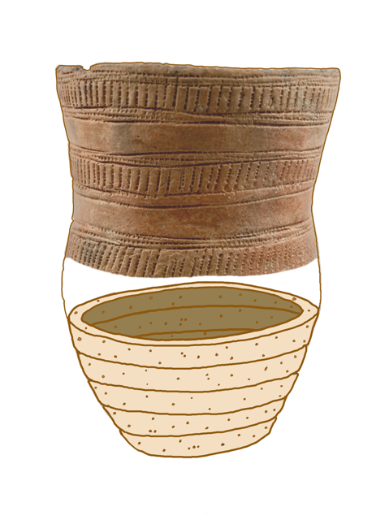

Coils of clay are placed one on top of the other to form the walls of the pot.

Activity

Try making your own Beaker using coils of air-drying clay and then use different techniques to decorate it. Below are examples of decoration made using twisted cord, sharpened pencils, fingernails and fingertips on slabs of air-drying clay.
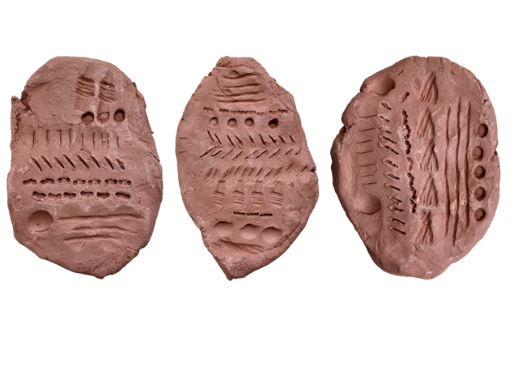

Different types of decoration on slabs of air-drying clay.

